Fig 1.0 below shows a typical 8 bit (byte wide) parallel Output port that can only be read from/written to 8 bits at a time (reading involves reading the output data currently stored at the port).

Two concurrently executing time-sliced processes, P1 and P2, are each involved in updating this device. Process P1 must only modify the data on bits 0 - 3 of the 8 available output lines while process P2 must only modify bits 4 - 7. Both processes are counting two separate external events (not shown) and updating their counts of this event on their corresponding four LED's. The problem here is that the output port is one single entity, that is, you cannot just write to 4 bits of it at a time, you have to read and write all 8 bits.
Ignoring overflows when the count of events for either process exceeds 15, write the pseudo code for each of the two processes below showing how the LED’s for that process are updated as a result of receiving the event and hence discuss what problems these two processes might face when running concurrently with each other.

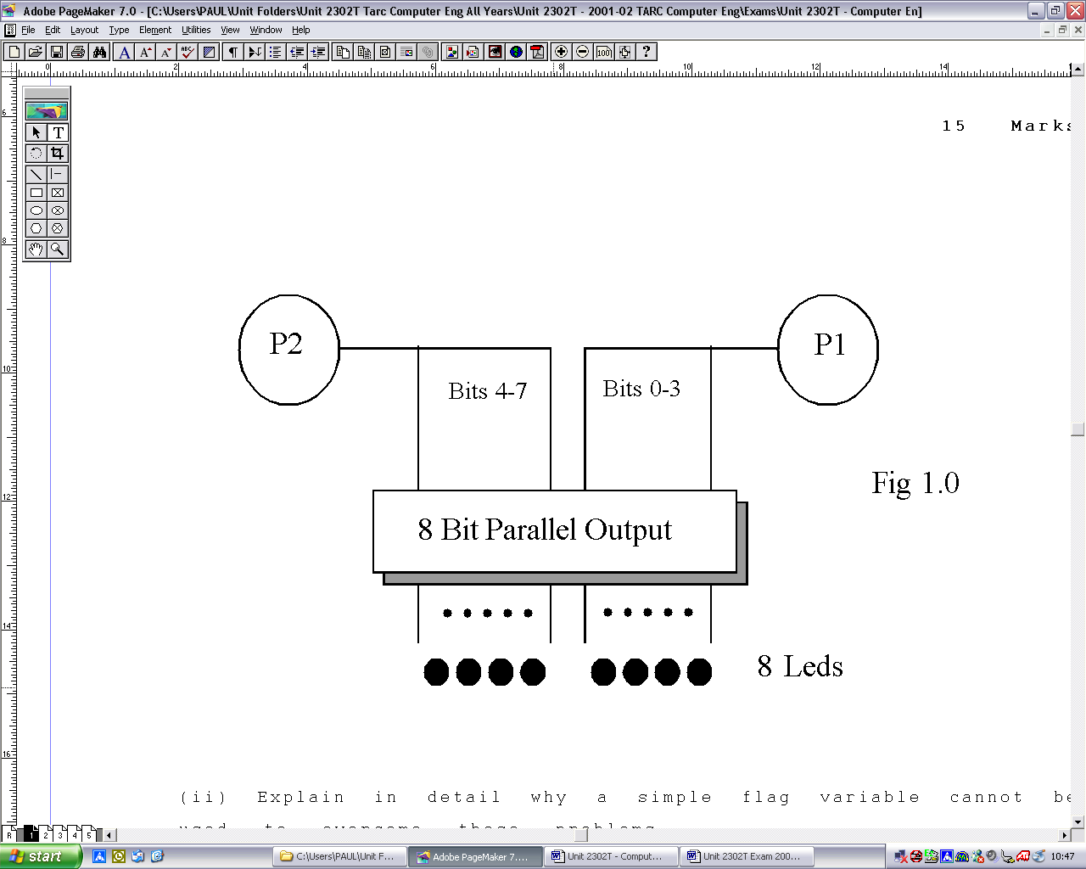

(ii) Explain in detail using suitable pseudo-code why a simple ‘flag’ type variable cannot be used to overcome the problems you identified above.
(iii) How would you solve the problem in a way that prevent indefinite lockout and provides a deterministic operation for both processes.

